|  |
| --- |
|  |
| Multimedia Project description |
|  |
| **Created by:** |
| 1. **Hazem Yahya Sayed** 2. **Mokhtar Sameh Mokhtar** |

|  |
| --- |
|  |

In the picture below

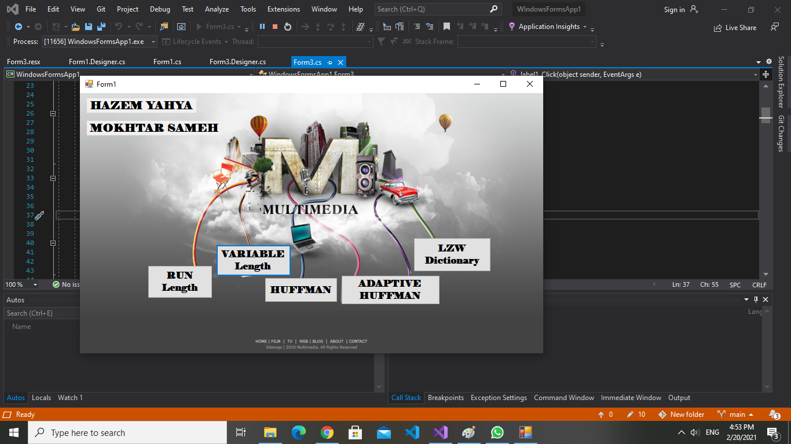Press any button to each algorithm

I will start with run length algorithm in the picture below, Input the text to be encoded and then press the “encode” button , And then press decode to get the decode string

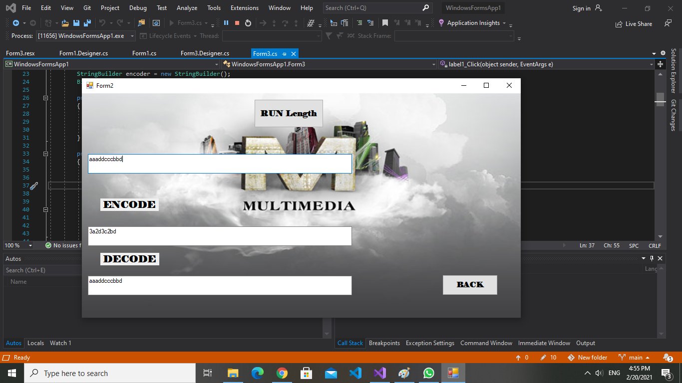

Press close to return to the algorithms page and then choose another algorithm , I choose variable length algorithm 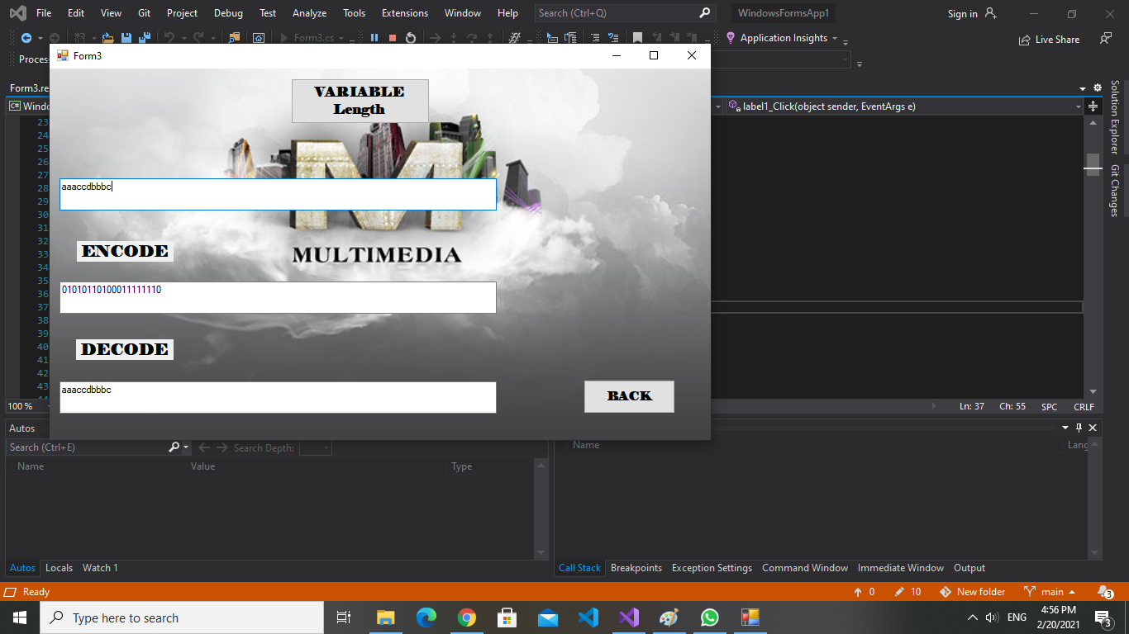

The picture above describe the steps and then press close to get another algorithm , I choose Adaptive Huffman Algorithm .

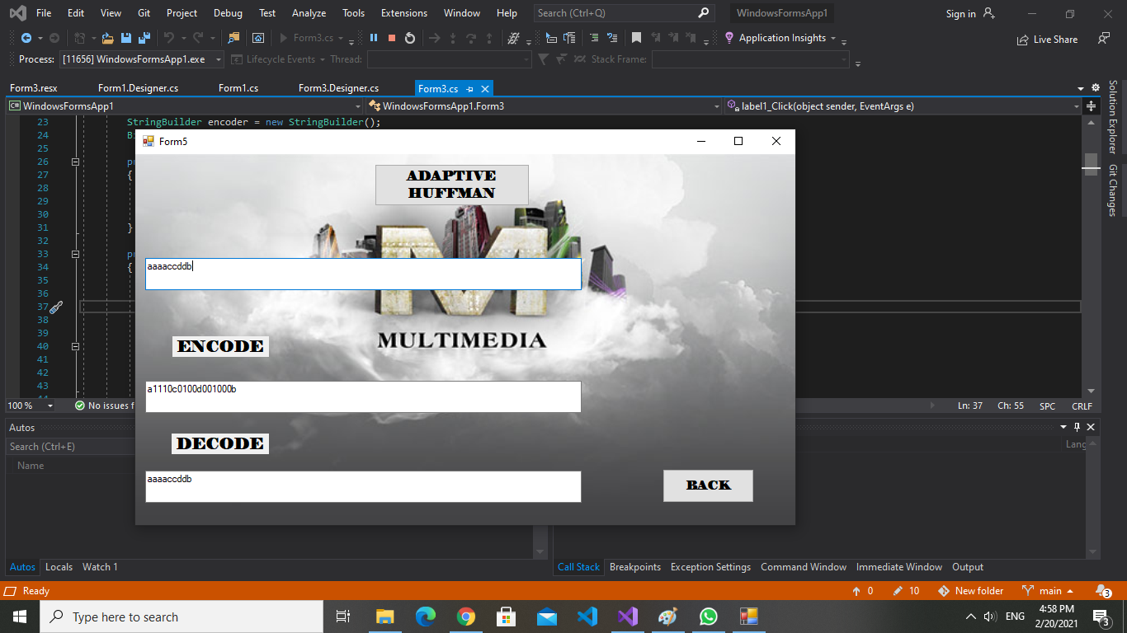

Then I pressed close and get the next algorithm “Huffman Algorithm”

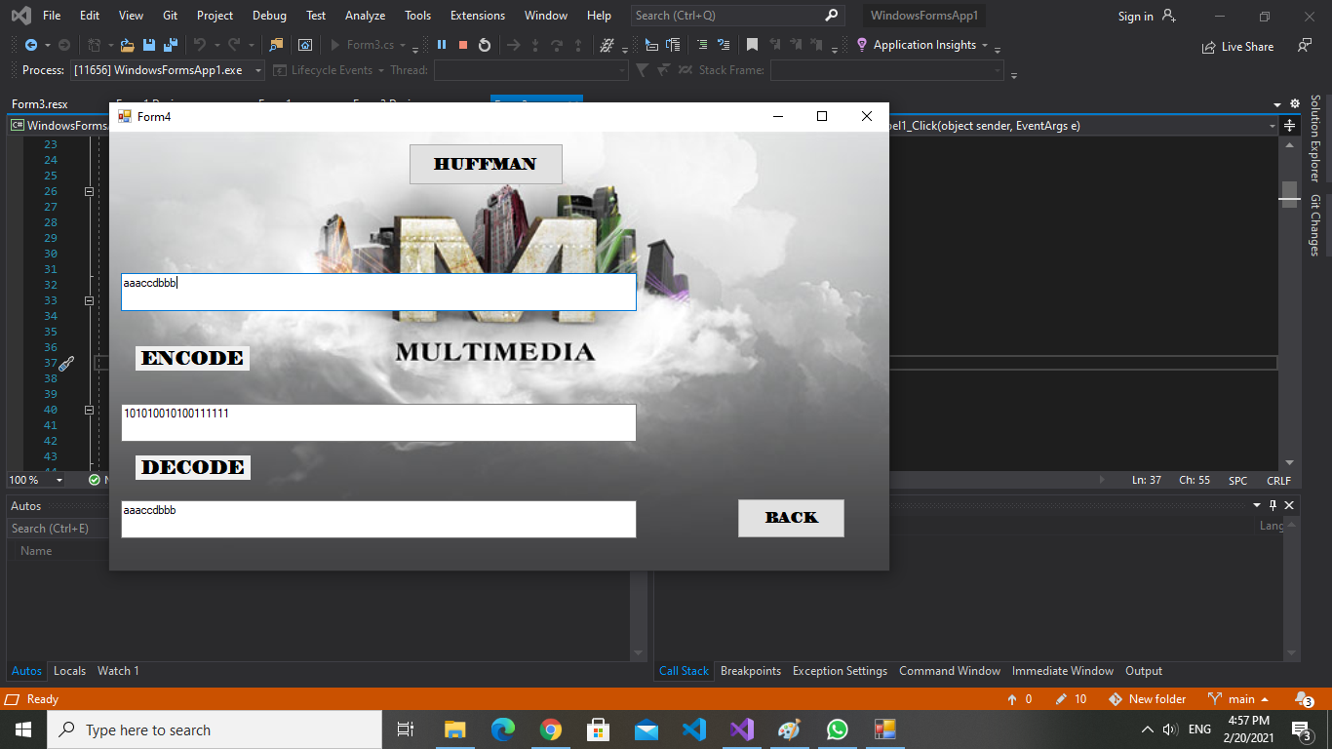

The same steps is done to get the results with this algorithm ang get the next And finally the last algorithm “LZW Dictionary “